User Creation

- Log in to www.sipri.gov.in
- Log in with District Admin login credentials
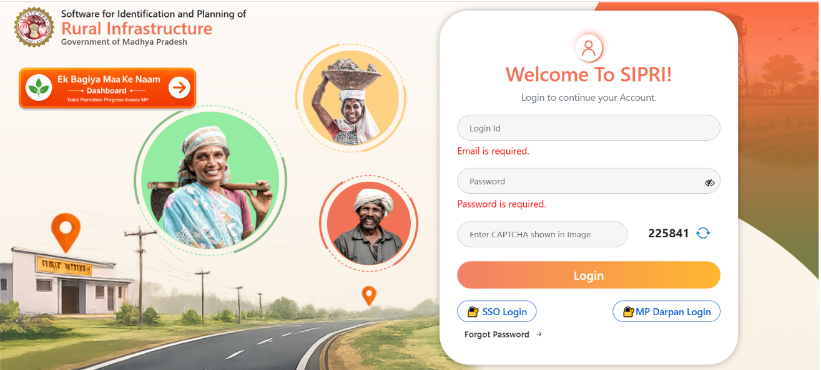

- At Home Page Select User Management Tab
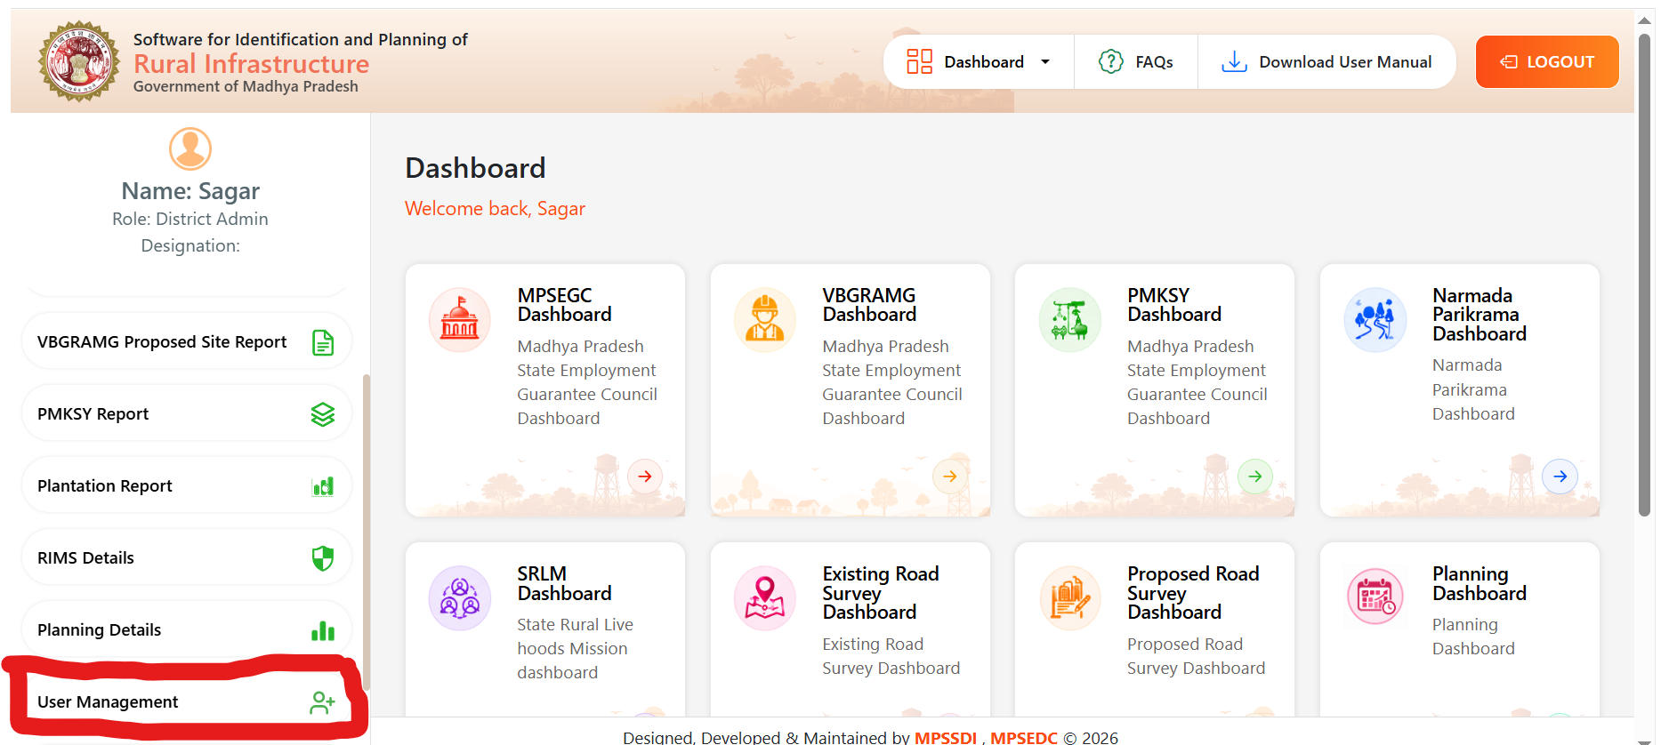

- At User Management Page Click to “Add New User” if user not registered on SIPRI

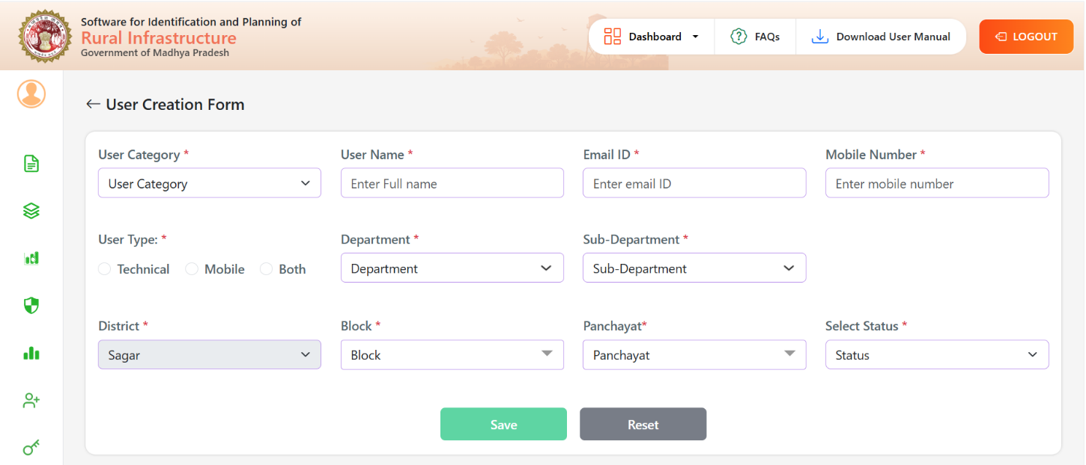

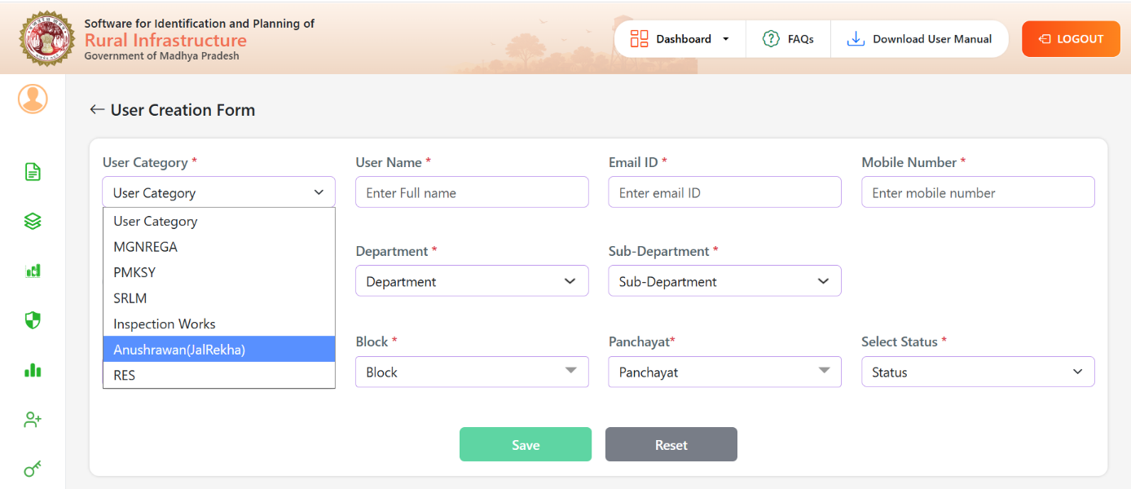
- At User Creation Page Select the Category “ Anushravan” from Drop down

- Fill the other details User name, Email id, Mobile Number ,User Type ( Select mobile for mobile user), Department, Sub-Department, Block ,Panchayat and Select Status ( which should be Active) and Click to Save the data

For Existing User:

- Click to search button at User Management Screen
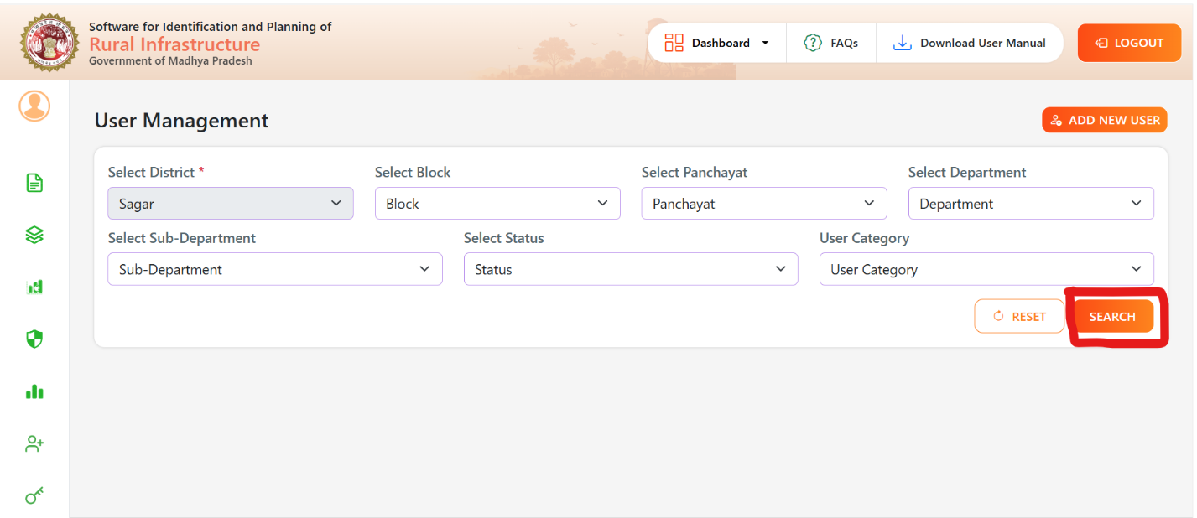

- It shows the list of all the Existing User
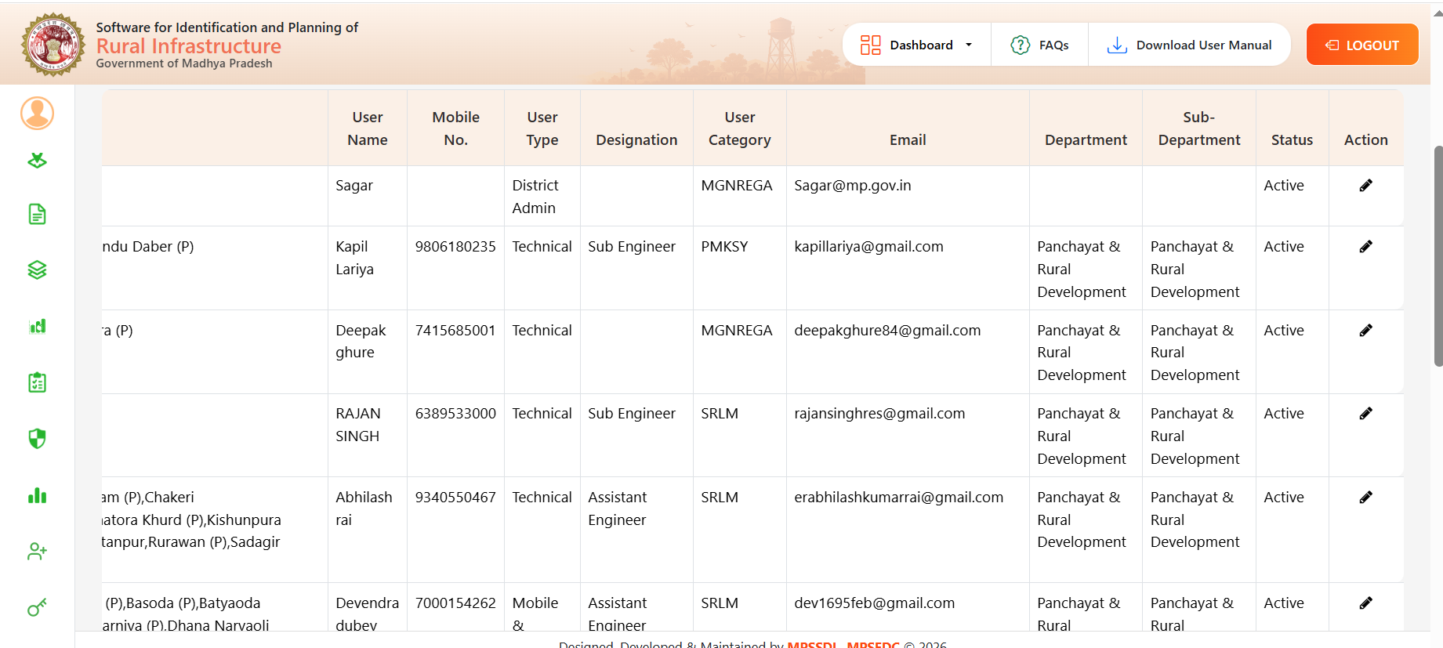

- Search the desired user by using Search Bar or Scrolling
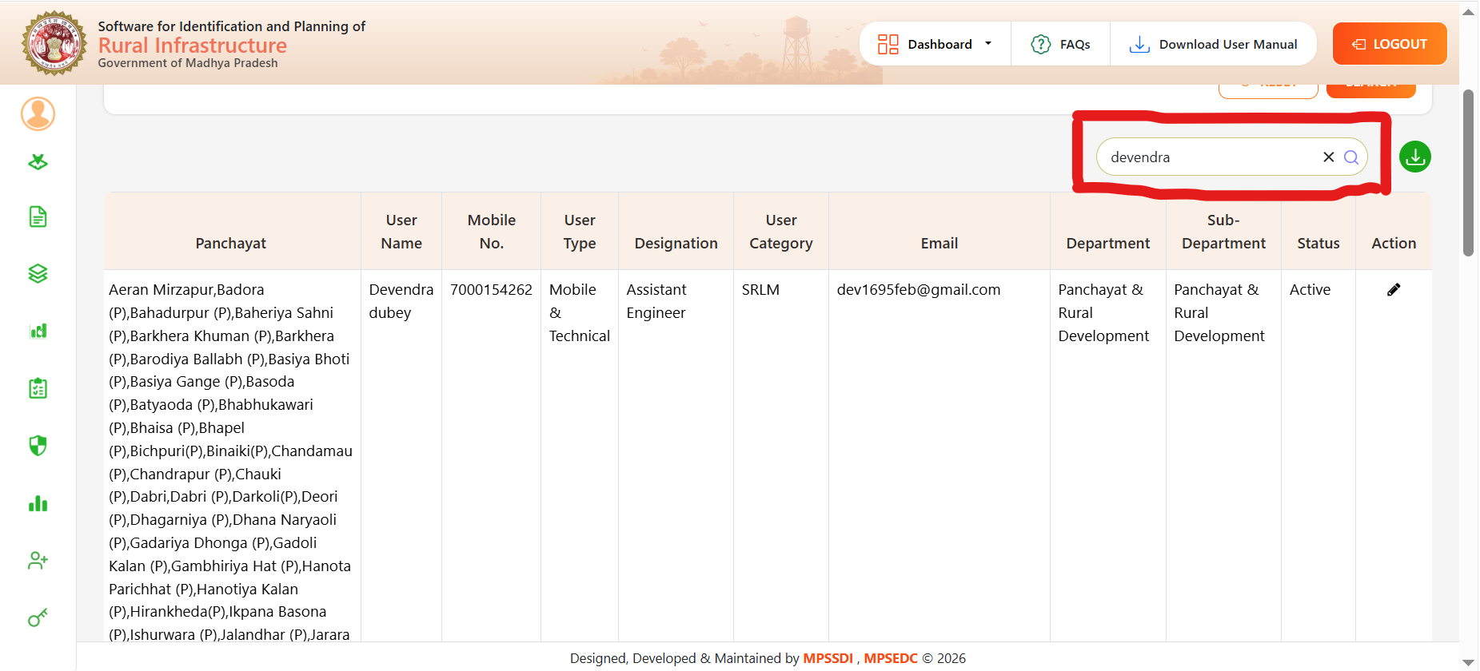

- Click on Action Button

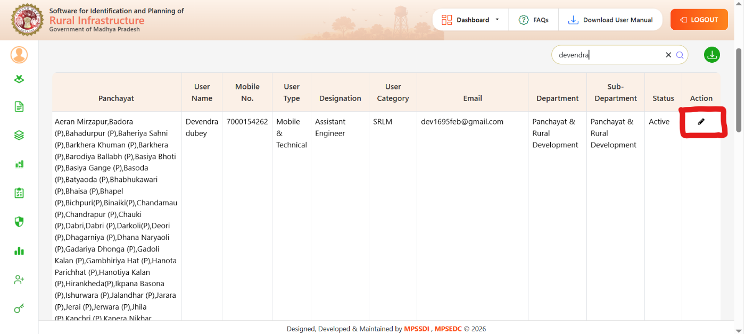

- It redirect to update user page. Here update/change the user category to “ Anushrawan” and other details(if required) and click to update the user
